**SUPERSET ID: 6372353 NAME : VARUNS**

**Exercise 3: Stored Procedures**

**Scenario 1:** The bank needs to process monthly interest for all savings accounts.

* + **Question:** Write a stored procedure **ProcessMonthlyInterest** that calculates and updates the balance of all savings accounts by applying an interest rate of 1% to the current balance.

**Answer**

**Create Table**

**Applies a 1% interest to the current balance of all rows in the SavingsAccounts table.**

**Output**



**Folder Structure**

**Scenario 2: The bank wants to implement a bonus scheme for employees based on their performance.**

* + Question: Write a stored procedure UpdateEmployeeBonus that updates the salary of employees in a given department by adding a bonus percentage passed as a parameter.

**Answer**

**Create Table**

**Accepts the department name and bonus percentage as input parameters and increases the salary of all employees in that department by the given percentage.**

**Output**

**Folder Structure**

**Scenario 3: Customers should be able to transfer funds between their accounts.**

* + Question: Write a stored procedure TransferFunds that transfers a specified amount from one account to another, checking that the source account has sufficient balance before making the transfer.

**Answers**

**Create Table**

**Transfer Funds**

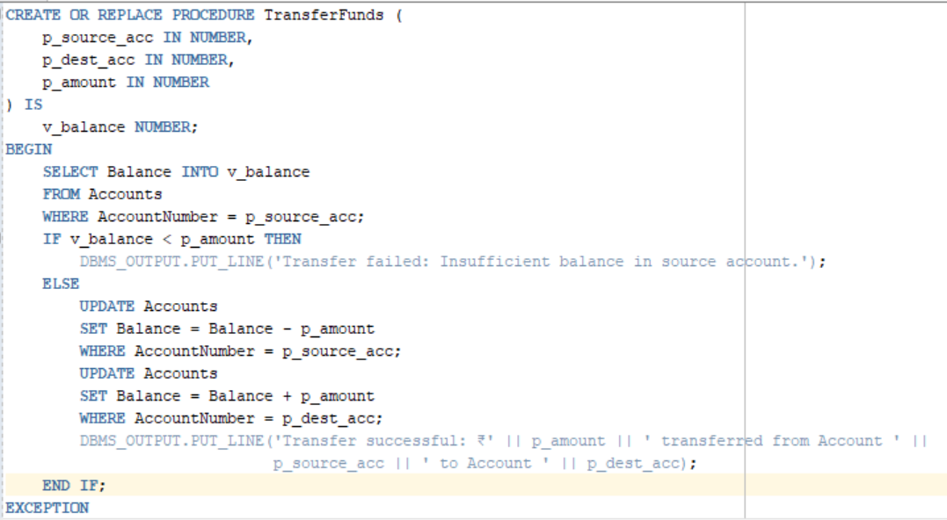

**Output**

**Folder Structure**

